We as fabric duct company offers imported fabric / textile duct in Pakistan that has optimized air diffusion solutions and guaranteed air performance.

Coming in a wide variety of shapes and colors allowing free reign on design and imagination. Their advanced technology can be used for refrigerating, air-conditioning, refreshing, ventilating, or heating any atmosphere or alternatively transporting treated air.

Applications include all types such as; industry, public buildings, commercial high rise, food-processing plants, logistics warehousing, pharmaceutical, etc.

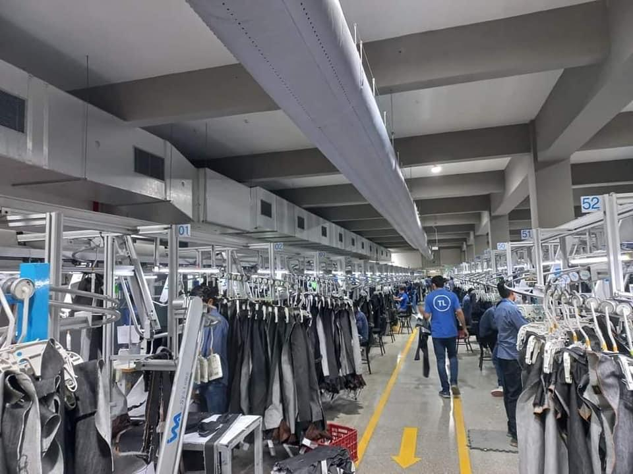

Meta Description:

We as fabric duct company in Pakistan import fabric/textile duct from Europe. The main benefit of textile duct is that it is easy to install and less expensive than other metal ducts.

Keywords:

Fabric duct companies in Pakistan, textile duct companies in Pakistan, Lahore, karachi, Islamabad, Faisalabad

Title: Fabric / Textile Duct in Pakistan – Welkin Solutions

URL: welkin.com.pk/products/hvac/Fabricduct